Good-Morning Muffins
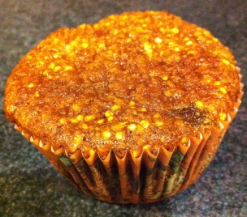
Makes 12 servings, one muffin is a serving
Preparation: 45 min. Cook approx. 25 min.

Ingredients:
- ½ c uncooked quinoa **
- ½ c skim milk
- 1 ½ T ground flaxseed
- ½ c raisins
- ½ c old-fashioned oatmeal (Bob’s Red Mill gluten free used in the nutrients)
- ½ c almond meal
- 1 tsp. baking soda
- ¼ tsp. salt
- ¼ tsp. ground cinnamon
- 2 egg whites
- ¼ c agave
- ¼ c honey
Directions:
Combine the quinoa, skim milk, and ground flaxseed in a medium bowl. Let stand 30 min.
**You can choose to cook the quinoa prior (according to package directions with the skim milk instead of water) to mixing in the muffin mix or you can leave uncooked. Uncooked adds a little crunch.

Place raisins in heat-proof bowl and cover with boiling water. Let stand 15-30 min. to plump. Drain and set aside.

Preheat the oven to 350 degrees. Line the 12 muffin cups with paper liners.

Ground the oatmeal in a food processor till very fine. Then, in the food processor mix together eggs, honey, agave, oatmeal, almond meal, baking soda, salt, and cinnamon. Take out the blade and stir in the quinoa mixture and raisins.

Pour the batter in the muffin cups till ½ - ¾ full. Bake for approx. 25 min. until browned on top. Cool before serving.
Nutrients: 142 calories, 4g protein, 24.3g carbohydrates, 3.5g fat

